AYYA NADAR JANAKI AMMAL COLLEGE
(Autonomous, affiliated to Madurai Kamaraj University, Madurai, Re-accredited (3rd cycle) with ‘A’ Grade (CGPA 3.67 out of 4) by NAAC and recognized as College of Excellence& Mentor College by UGC, Star College by DBT and Ranked 51st at National Level in NIRF 2019)
SIVAKASI

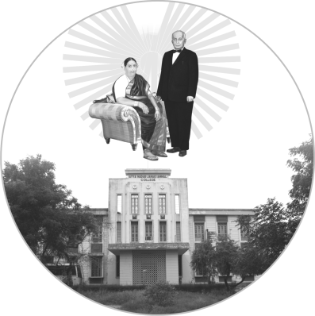
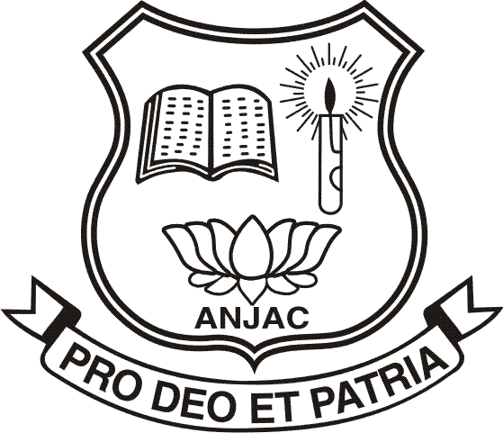

LIST OF MEDALISTS
FOR THE YEAR
2018 – 2019

57thCOLLEGE DAY & FOUNDERS’ DAY
07 – 03 – 2020

AYYA NADAR JANAKI AMMAL COLLEGE
(Autonomous, affiliated to Madurai Kamaraj University, Madurai, Re-accredited (3rd cycle) with ‘A’ Grade (CGPA 3.67 out of 4) by NAAC and recognized as College of Excellence& Mentor College by UGC, Star College by DBT and Ranked 51st at National Level in NIRF 2019)

SIVAKASI
Provisional List of Medalists for the year 2018 – 2019

UNDER GRADUATE COURSES

S.No. | Mathematics
 | I Prize |  | M. Mahalakshmi
 | Thiru. P. AyyaNadar Gold Medal
 | II Prize Silver Medal |  | S. Jeyashri
 | Physics
 | I Prize |  | B. Gurupriya
 | Thirumathi. A. JanakiAmmal Gold Medal
 | II Prize Silver Medal |  | R. Manjuladevi
 | Chemistry
 | I Prize |  | S. Yuvarani
 | Thiru. S. Palaniappa Nadar Gold Medal
 | II Prize Silver Medal |  | G. Malathi
 | Plant Biology and Plant Biotechnology
 | I Prize |  | S. Revathi
 | Thirumathi. P. Nagammal Gold Medal
 | II Prize Silver Medal |  | P. Sabiya
 | Zoology
 | I Prize |  | A. Poun Mary
 | Thiru. A. Grahadurai Gold Medal
 | II Prize Silver Medal |  | T. Poornakala
 | Computer Science
 | I Prize |  | R. Varshini
 | Thiru. A. Vairaprakasam Gold Medal
 | II Prize Silver Medal |  | N. Muthu Selvi
 | Microbiology
 | I Prize |  | A. Nirmala Devi
 | Thirumathi. A. JanakiAmmal Gold Medal
 | II Prize Silver Medal |  | S. Sajeetha Rahuman
 | Biotechnology
 | I Prize |  | J.N. Aysha Rizwana
 | Thiru. P. Ayya Nadar Gold Medal
 | II Prize Silver Medal |  | V. Vinitha Meena
 | Visual Communication
 | I Prize |  | M.Arunkumar
 | Thirumathi. A. JanakiAmmal Gold Medal
 | II Prize Silver Medal |  | S. Saravanan
 | Computer Applications
 | I Prize |  | S. Salai Selva Kumari
 | Thiru. P. Ayya Nadar Gold Medal
 | II Prize Silver Medal |  | K. Gayathri
 | Physical Education, Health Education and Sports
 | I Prize |  | S. Periyandavar
 | Thiru. A. Subash Chandra Bose Gold Medal
 | II Prize Silver Medal |  | A. Kamesh
 | Economics
 | I Prize |  | K. Satheeshkumar
 | Thiru. A. Ramamurthy Gold Medal
 | II Prize Silver Medal |  | S. Pavithra
 | English
 | I Prize |  | P. Ragavi
 | Thirumathi. A. JanakiAmmal Gold Medal
 | II Prize Silver Medal |  | M. Siva Narayani
 | Commerce
 | I Prize |  | P. Umadevi
 | Thiru. V. AyyanKodiswaran Gold Medal
 | II Prize Silver Medal |  | P. Kalavathi
 | Commerce (Computer Applications)
 | I Prize |  | K. Saravanisha
 | Thiru. P. AyyaNadar Gold Medal
 | II Prize Silver Medal | G. Murugan
 | Commerce (E-Com.)
 | I Prize |  | V. Vidhya
 | Thirumathi. A. JanakiAmmal Gold Medal
 | II Prize Silver Medal |  | K. Prathap
 | Commerce (Corporate Secretaryship)
 | I Prize |  | G. Madhumitha
 | Thiru. P. AyyaNadar Gold Medal
 | II Prize Silver Medal |  | T. Poornima
 | Business Administration
 | I Prize |  | M. Kanimozhi
 | Thiru. G. Athipathy Gold Medal
 | II Prize Silver Medal |  | U. Siva Priya
PART I & PART II LANGUAGE PAPERS

 | Tamil(B.A. / B.Sc.)
 | I Prize |  | G. Saranya
 | Thiru. A.S. Adhipan Kennedy Bose Gold Medal
 | II Prize Silver Medal |  | S. Hemashalini
 | Hindi(B.A. / B.Sc.)
 | I Prize |  | M. Vishnu Devi
 | Thiru. G. Abiruben Gold Medal
 | II Prize Silver Medal |  | R. Siva Sankari
 | English(B.A. / B.Sc.)
 | I Prize |  | M. Vishnu Devii
 | Thiru. R. AyyaNadarKarthick Gold Medal
 | II Prize Silver Medal |  | R. Prathisha Sankar
POST GRADUATE COURSES
 | Mathematics
 | I Prize |  | S.B.Ramkumar
 | Thiru. R. Janaki Ramanan Gold Medal
 | II Prize Silver Medal |  | V. Gurubharathi
 | Physics
 | I Prize |  | R. Pandieswari
 | Thirumathi. Bhavani Grahadurai Gold Medal
 | II Prize Silver Medal |  | P. Aparna
 | Chemistry
 | I Prize |  | J. Uva Rani
 | Thirumathi. Meera Vairaprakasam Gold Medal
 | II Prize Silver Medal |  | M. Subalakshmi
 | Botany
49. | I Prize |  | M. Jothipraba
 | Thirumathi. Kanchana Subash Chandra Bose Gold Medal
50. | II Prize Silver Medal |  | K.Shanmuga Sundari
 | Zoology
51. | I Prize |  | J. Jeyavani
 | Thirumathi. Madhana Ramamurthy Gold Medal
52. | II Prize Silver Medal |  | A.B. Mohanapriya
 | Computer Science
53. | I Prize |  | S. Thanganila
 | Thiru. P. AyyaNadar Gold Medal
54. | II Prize Silver Medal |  | T. Keerthana
 | Microbiology
55. | I Prize |  | K. Arjun Kumar
 | Thiru. P. AyyaNadar Gold Medal
56. | II Prize Silver Medal |  | S. Malathi
 | Biotechnology
57. | I Prize |  | W. Stalin
 | Thirumathi. A. Janaki Ammal Gold Medal
58. | II Prize Silver Medal |  | P. Sumalatha
 | Computer Applications
59. | I Prize |  | A. Lakshmi Priyanka
 | Dr. A. Pownraja Gold Medal
60. | II Prize Silver Medal |  | K. Ajoy Balaji
 | Tamil
61. | I Prize |  | S. Manikandan
 | Thirumathi. A. JanakiAmmal Gold Medal
62. | II Prize Silver Medal |  | S. Valarmathi
 | Economics
63. | I Prize |  | B. Iswarya
 | Thiru. P. AyyaNadar Gold Medal
64. | II Prize Silver Medal |  | R. Archana
 | English
65. | I Prize |  | A. Catherin
 | Thirumathi. A. JanakiAmmal Gold Medal
66. | II Prize Silver Medal |  | T. Karthikeyan
 | Commerce
67. | I Prize |  | R. Chella Priya
 | Thiru. P. AyyaNadarGold Medal
68. | II Prize Silver Medal |  | S. Sri Lavanya
 | Commerce (Computer Applications)
69. | I Prize |  | S. Divya
 | Thirumathi. A. JanakiAmmal Gold Medal
70.  71.  72.  73.  74. | II Prize Silver Medal  Master of Philosophy  Tamil  I Prize  Thiru. P. AyyaNadar Gold Medal  II Prize  Commerce  I Prize  Thirumathi. A. JanakiAmmal Gold Medal  II Prize |  | V. Jeyaraj  K. Govindammal  K. Anuradha  M. Yogalakshmi  P. Veera Selvi
 | CONVENER |  | PRINCIPAL

